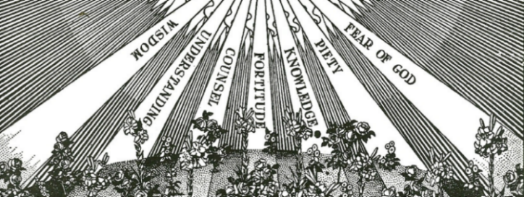

SPONSOR ELIGIBILITY CERTIFICATE
I certify that I,
__________________________________________ am a practicing member of :
Sponsor’s Name ____________________________________________ parish in _________________________________
Parish Name City/State

I accept the invitation to be the sponsor at the Confirmation of ___________________________________
Candidate’s Name

I truthfully state all of the following:
- I have received the Sacraments of Baptism, Eucharist, and Confirmation in the Catholic Church
- I am at least 16 years of age
- I am not the parent of the Confirmation candidate
- I am not married outside the Catholic Church
- I renounce Satan and all his works and all his empty promises
- I believe in God the Father Almighty, creator of heaven and earth; in Jesus Christ His only-begotten Son Our Lord who was conceived by the Holy Spirit, born of Virgin Mary, suffered under Pontius Pilate, was crucified died and was buried, descended into hell, rose from the dead, ascended into heaven and sits at the right hand of God the Father Almighty; and in the Holy Spirit, the holy Catholic Church, the communion of saints, the forgiveness of sins, the resurrection of the body and life everlasting
- I believe all the teachings of the Roman Catholic Church and strive to live by them.
- I attend Mass every Sunday and Holy Days of Obligation; I receive the Sacraments of Penance and the Holy Eucharist regularly and have done so recently.
- I will pray for my Confirmand and do all I can to teach him/her the Faith and promote his/her salvation.
Sponsor's Signature: ___________________________________

Priest’s Certification: I certify that __________________________________ is a member of this parish, is in full communion with the Catholic Church, is to the best of my knowledge able to assume the responsibilities of the role of Confirmation Sponsor.

______________________________________
Priest’s Signature / Date
PARISH SEAL **Please Note This form must be signed by the Pastor of the parish with which the sponsor is registered

21

