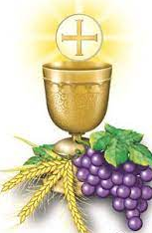
St. Isidore the Farmer Catholic Church
14414 St. Isidore Way
Orange, VA 22960

REGISTRATION FOR FIRST COMMUNION

***Important***
Submit a copy of your child’s Baptismal certificate to the front office. If your child was baptized at another parish, please have that church fax a copy of their certificate to our office.

Name ________________________________________________
Place of Birth ____________________________________________________
Date of Birth ______________________________________
Father’s Name ________________________________________ Phone # _______________________
Mother’s Name (include Maiden Name) _______________________________________ Phone # _______________________
Home Address: _____________________________________________________________________
____________________________________________________________________-

Church of BAPTISM______________________________________________________
Church’s Address________________________________________________________
_______________________________________________________
Date of Baptism____________________________

